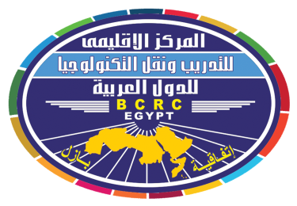

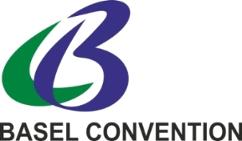

REGISTRATION FORM
TO BE COMPLETED FOR EACH PARTICIPANT

Regional workshop on review and discussion of guidance to assist Parties in developing their national waste prevention and reduction strategies and responses by government officials on their applicability
----------------------------------------------
23-24 February 2019 , Cairo, Egypt .

حلقة عمل إقليمية بشأن إستعراض ومناقشة التوجيهات الإرشادية الخاصة بمساعدة الأطراف فى وضع إستراتيجياتها الوطنية الخاصة بمنع النفايات والتقليل منها وردود المسؤولين الحكوميين بشأن قابليتها للتطبيق
23-24 فبراير 2019 ، الإسكندرية – جمهورية مصر العربية
Please type or print clearly (do not use abbreviations) and return the completed form by Thursday, 31 January 2019 to: Ms. Mai Kamel, Administrative Officer of the BCRC-Egypt, E-mail: mai_bcrc_arabs@yahoo.com; kmostafa@sci.cu.edu.eg; Tel.: +2 (0) 235715115; Tel/Fax: +2 (0) 235701015

COUNTRY /ORGANIZATION
TYPE OF ORGANIZATION (please check one )
GOVERNMENT |  |  |  | UN SPECIALIZED AGENCY |  |  |  | IGO |  | NGO |  | BC/SC REGIONAL CENTRE
ACADEMIC INST. |  |  |  |  | BUSINESS/INDUSTRY |  |  |  | OTHERS (please specify)
PARTICIPANT DATA:
Mr. | Ms. |  | First name: |  |  |  |  |  |  |  | Last name:
Functional title:
Section/Department:
Complete mailing address, street address or p.o. box:
Post code: |  |  |  |  |  | City: |  |  |  |  | Country:
Telephone: (including country and city code) |  |  |  |  |  | Mobile Telephone: (including country code) |  |  |  |  | E-mail Address:

