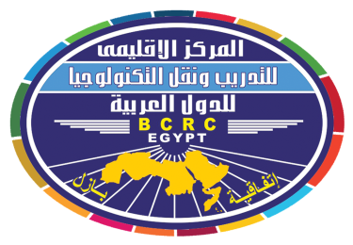

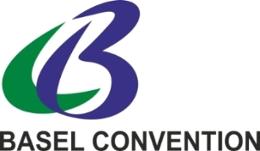

REGISTRATION FORM FOR NATIONAL FOCAL POINT
TO BE COMPLETED FOR EACH PARTICIPANT

Regional workshop on review and discussion of guidance to assist Parties in developing their national waste prevention and reduction strategies and responses by government officials on their applicability
----------------------------------------------
23-24 February 2019 , Cairo, Egypt .
حلقة عمل إقليمية بشأن إستعراض ومناقشة التوجيهات الإرشادية الخاصة بمساعدة الأطراف فى وضع إستراتيجياتها الوطنية الخاصة بمنع النفايات والتقليل منها وردود المسؤولين الحكوميين بشأن قابليتها للتطبيق
23-24 فبراير 2019 ،الإسكندرية – جمهورية مصر العربية
Please type or print clearly (do not use abbreviations) and return the completed form by Thursday, 31 January 2019 to: Ms. Mai Kamel, Administrative Officer of the BCRC-Egypt, E-mail: mai_bcrc_arabs@yahoo.com; kmostafa@sci.cu.edu.eg; Tel.: +2 (0) 235715115; Tel/Fax: +2 (0) 235701015

ORGANIZATION:
COUNTRY
PARTICIPANT DATA:
Mr. | Ms. |  | First name: |  |  | Last name:
Functional title:
Section/Department:
Complete mailing address, street address or p.o. box:
Post code: |  |  |  | City: |  | Country:
Telephone: (including country and city code) |  |  |  | Mobile Telephone: (including country code) |  | E-mail Address:
ONLY FOR REPRESENTATIVES ELIGIBLE FOR FINANCIAL SUPPORT:
ARE YOU REQUESTING FINANCIAL SUPPORT? |  |  |  |  |  | YES NO
Nationality: |  |  |  | Date of birth (dd/mm/yy): |  | Place of birth:
An important notes regarding financial support:
- This form should be submitted by 31 January 2019.
- Depending on the availability of funds, financial assistance will be made available to support the participation of one representative per Country. It is essential that we receive completed registration dossiers (registration form and copy of passport identification page) by the deadline indicated above to process travel support, where applicable. We will not be in a position to process travel for late nominations.

